Ardenwald – Johnson Creek Neighborhood District Association Minutes
11-27-23
The meeting was hosted at Milwaukie Café & Bottle Shop and was called to order at 6:34pm.

Attendees
Chris Holle-Bailey, Chair
Steve Smith, Flag Swag committee chair
Bill Bateman
Rita Lynn
Elvis Clark, Transportation & Safety Representative
Lane Rollins, concert committee chair
Lisa Gunion-Rinker, Land Use Chair
Captain Ryan Burdick
Travis Holle, Land Use Assistant
Matt Rinker, Vice Chair
Micheal Osborne, Assistant Finance Director, City of Milwaukie

Police Report

Captain Burdick reported that back on 10-25-23 there was a DV Sweep of Clackamas County, it’s 20th Annual event including 200 agencies and 16 states. In Clackamas, the operation made 10 arrests and an additional 92 attempts to locate and arrest suspects with DV related arrest warrants. He also reported that on 10-28-23 MPD helped with the “Craft With a Cop” event held at Milwaukie Floral and celebrated Halloween in downtown Milwaukie between 1-4pm with a Trick or Treat event and handed out candy to children.

Three officers: Jonathan Morton, Tim Cleary, and Kwasean Akom graduated from the State of Oregon 16-wk police academy on October 13th. Officer Cleary received top academic honors and was asked by fellow officers to give the graduation speech. Officer James Smith and Vincent Barnett left for the police academy on November 13th and will attend the next 4 mths and graduate in March.

October had many firearm recoveries. The Sunny Corner Market was robbed – 3 men armed w/ handguns robbed the convenience store at Monroe & Home Ave. Handguns were recovered. An officer made a traffic stop and seized 2 handguns and linked the 2 men to a shooting in Ptld. A third contact arrested a man for Unlawful possession of a firearm.

In November, the Clackamas County Sheriff’s Office led a retail theft operation. MPD participated. The 10hr operation resulted in 28 arrests on multiple charges and recovery of more than $5000 stolen merchandise and a stolen vehicle. Deputies were able to clear more than 20 arrest warrants.
The annual “Shop with a Cop” event will be held December 2nd at the Clackamas Fred Meyer. Last year 168 kids and over 100 officers participated. This event is supported by the Clackamas County Peace Officer Benevolent Foundation. (CCPOBF.org)

Robbie Nashif from the Kaizer PD and CCSO traffic team will be sworn in on December 4th. He has held the top ticket writer position in Clackamas County for the last 5-7 years and will begin patrolling in Milwaukie.

City Financial Report

Micheal Osborne presented the People’s Annual Financial Report for the City of Milwaukie which contained a brief overview of the 2022 fiscal year and included some of the City’s financial history for the past 4 years. Neighbors asked questions pertaining to the NDA budget and funding NDA events, and the addition of a section in the financial report that shows specific progress on current bond measures funded by the community, such as the new library, and new city hall. This section would showcase our progressive push as a community to grow and invest where we live and our forward momentum on paying off these bonds and thinking of the future and what other investment we can achieve.

Committee Reports

Chair: The Ptld side of the NDA has a new voting district and are now determining if our Ptld NDA should be under a new District Coalition and not SEUL. There are discussions happening between the Ardenwald -JC, Eastmoreland, Sellwood, Woodstock, and Brentwood-Darlington NDAs that want to stay under SEUL jurisdiction.

Land Use

- Hillside Ct. - they are planning to upgrade existing equipment on top of the Hillside Manor Tower.

- A group met Nov 5th to discuss the 42nd and JCB intersection and determined that this project includes more than just the addition of the 61 or so proposed housing units at the site, and that a bigger picture of all JCB intersections from 32nd to 45th needs to be completed. It could be that the bottleneck at 45th as determined by the Kittleson traffic study, may be alleviated using an electric eye or some such at that intersection. Chris HB will create a letter of inquiry for the City from both the AJCNDA and the Llewellin NDA requesting this traffic study.

- The Land Use Chair has received complaints from neighbors concerning the cottage cluster development on 40th Ave. After viewing the site, it is unfortunate that the 1st cottage cluster in the NDA should look like this one. The houses appear to be 2 story full-size homes stuck closely together with no possible greenspace between them. The comments received stated that this project would have looked better as an apartment.

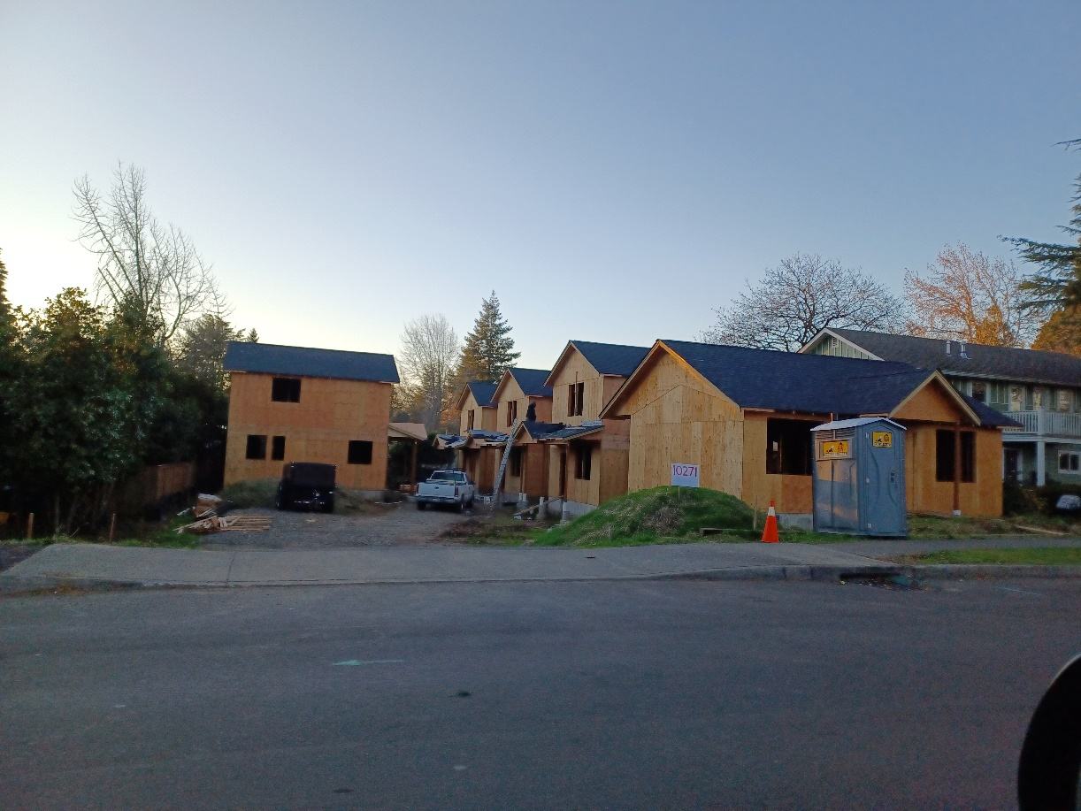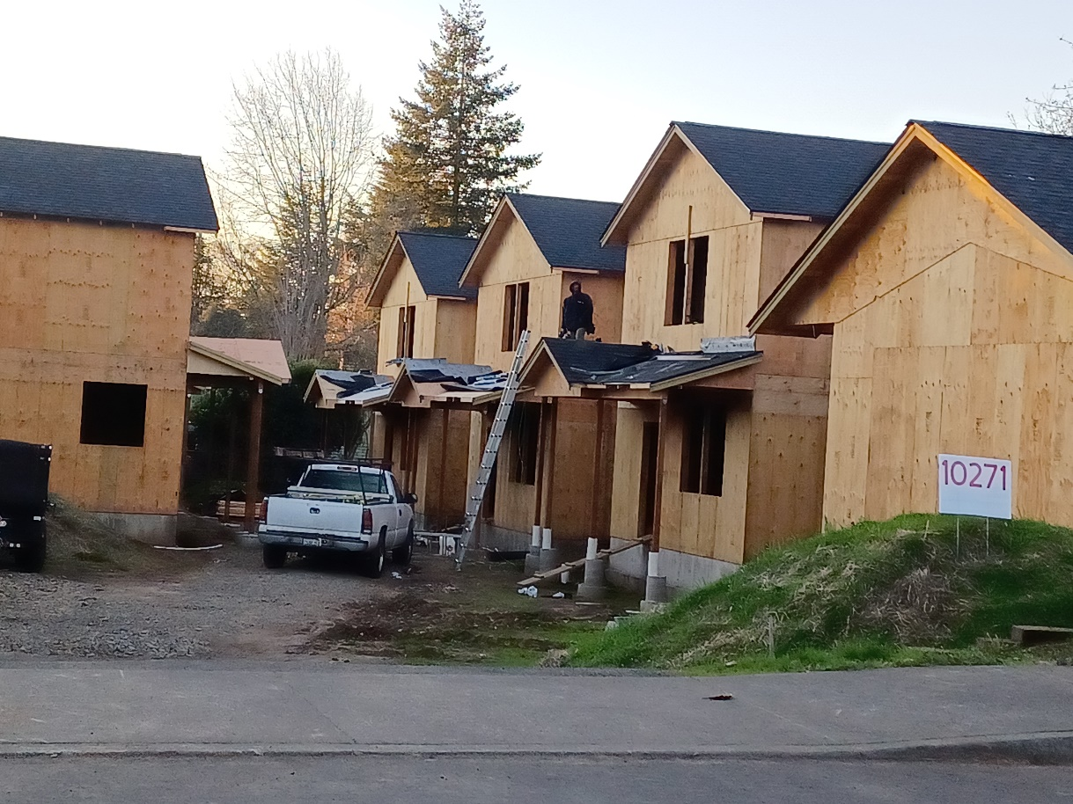

-VR-2023-005 requests a 6’ section of fencing in the front of the house at 9631 SE 42nd Ave that gives privacy to the garden in this yard.
- VR-2023-006, 3607 SE King site, which requested a setback variance that was granted is an enormous home that utilizes much of the lot and is in the dripline of the large cedar tree in the neighbor’s yard.
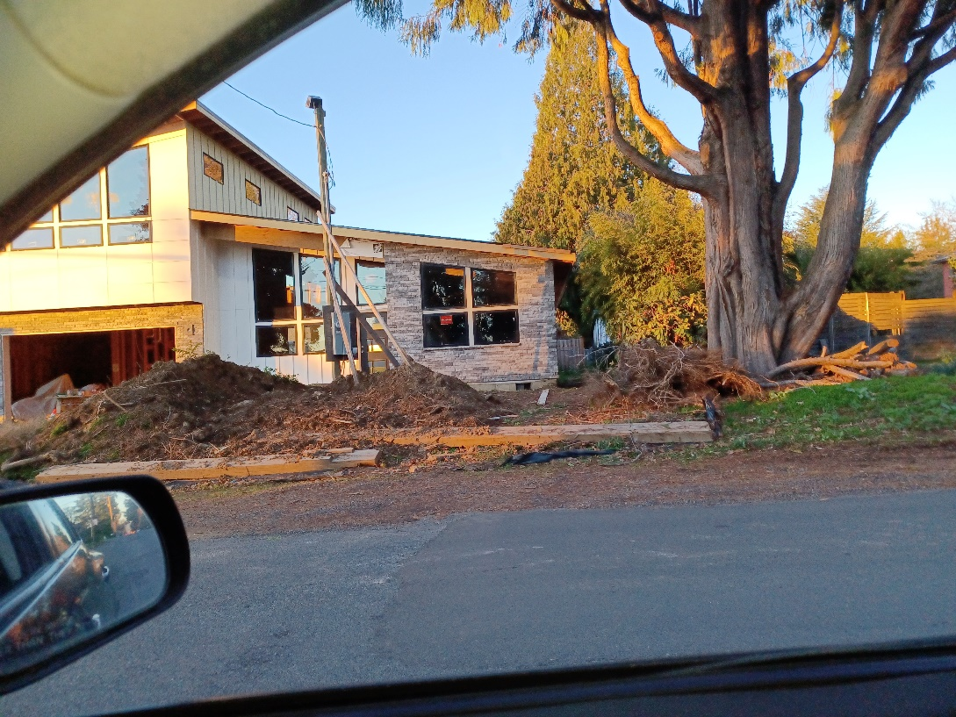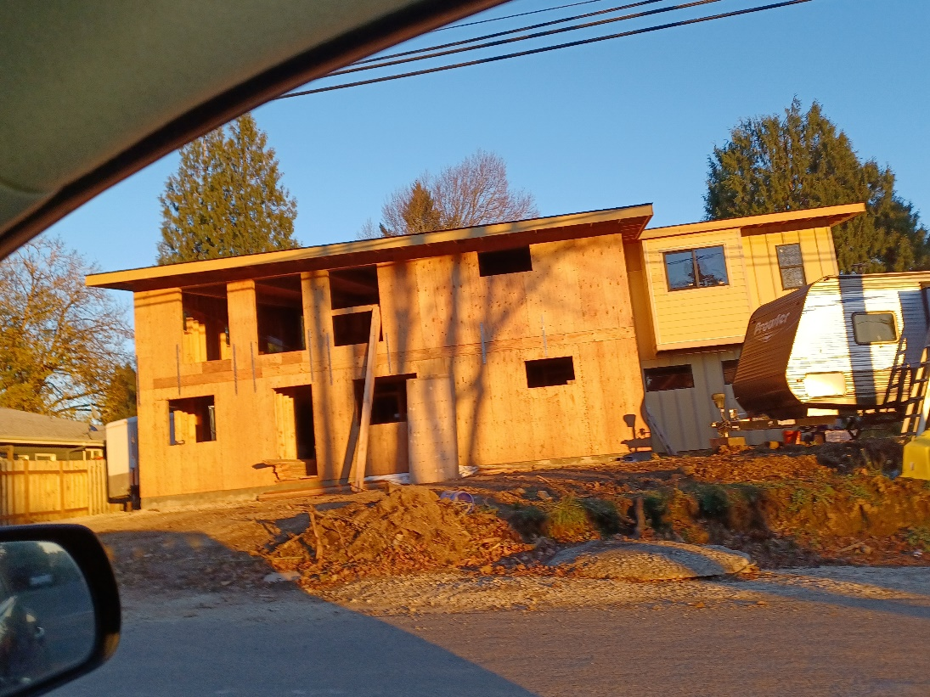

-Meek Street Stormwater Project creates a 1.54-acre parcel at the end of Balfour and Kelvin to place a stormwater retention facility utilizing RR property. Neighbors have complained that the area along the neighborhood between homes and the RR tracks on Malcolm Street are now being scrubbed to place a 30” pipe as part of this project. After reviewing this project, nothing was submitted to the NDA past the initial approval of the creation of the 1.54-acre site. The AJCNDA will contact Natalie at the City to learn about the scope/expansion of this project and discuss the displacement of wildlife along this long-known corridor that connects Johnson Creek to the neighborhood. Neighbors commented that multiple critters such as skunks, possums, coyotes, and raccoons took up residence on Balfour and surrounding streets to escape the destruction. The coyotes moved into Balfour Park where individuals bring their dogs off-leash to play and concerns about small dog safety have been raised when coyotes were seen during the daytime at the park. A planting plan for this corridor was discussed with a neighbor, and they were told no trees will be replanted in the corridor. The NDA has not seen a planting plan and would like further information.
Brief Discussion about upcoming events
December Potluck – Will be held at Milwaukie Café & Bottle Shop on December 10th 2:30-5pm. Neighbors should bring a dish to share and meet their neighbors. No business will be discussed at this event.
Winter Solstice – Chris HB, chair and coordinator, created 2 shifts to host the event. Chris, Travis, and Steve will host the 4-6 shift, and Steve, Lisa, and Lane will host the 6-8 shift. The NDA will be selling handwarmers, reusable glow sticks, and flag swag including 24 beanies for the event.
Concert Series Mtgs were discussed and a subcommittee for the concerts will be initiated.
The meeting adjourned at 8:08pm

